C29PE Tutorial 5 Questions with Answers – Market Failure and Government Intervention

- The following are problems that prevent markets from providing a socially optimal allocation of resources:
- Externalities
- Monopoly/oligopoly power
- Ignorance and uncertainty
- Public goods and services
- Merit goods

Match each of the above categories of problem to the following examples of failures of the free market. In each case assume that everything has to be provided by private enterprise: that there is no government provision or intervention whatsoever. Note that there may be more than one example of each category of problem. Note also that each of the following cases may be an example of more than one category of problem.

  - There is an inadequate provision of street lighting because it is impossiblefor companies to charge all people benefiting from it. (iv)
  - Advertising allows firms to sell people goods that they do not really want. (iii)
  - A firm tips toxic waste into a river because it can do so at no cost to itself. (i)
  - People may not know what is in their best interests and thus may underconsume certain goods or services (such as education). (v)
  - Firms’ marginal revenue is not equal to the price of the good and thus they donot equate MC and price. (ii)
  - Firms provide an inadequate amount of training because they are afraid that other firms will simply come along and ‘poach’ the labour they have trained. (i)

- Give two examples of each of the following:
  - External costs of production.
A factory that emits CO2 into the atmosphere causing global warming; a football ground built in a city centre that causes congestion/parking problems on matchdays.
  - External benefits of production.
Research and development by one firm that benefits others; re-forestation (benefits from CO2 reduction in atmosphere).

  - External costs of consumption.
Playing music loudly that annoys neighbours; irritation to others caused by the use of mobile phones in a public place: e.g. on trains.
  - External benefits of consumption
Benefits to others from people using medicines that cure infectious diseases; benefits to neighbours from people maintaining their own house and garden.

- Assume that a firm, operating in a perfectly competitive market, produces organic waste that has the effect of increasing the fertility of neighbouring farmland and thus reducing the farmers’ costs. It is impractical, however, to sell the waste to the farmers. The following table shows the firm’s private marginal costs and these external benefits to farmers from the firm’s production.
Output  (units) | Price  (£) | Marginal (private)  costs (£) | Marginal external  benefit (£) | Marginal social  cost (£)
1  2  3  4  5  6  7  8  9  10 | 20  20  20  20  20  20  20  20  20  20 | 16  15  15  16  17  18  20  22  24  27 | 6  5  4  3  2  2  2  2  2  1 | 10  10  11  13  15  16  18  20  22  26

  - Assuming no government intervention, how much will the firm produce to maximise profits? 7 units (where P (= MR) = MC (private))
  - Fill in the column for marginal social cost See table
  - What is the socially optimum level of output? 8 units (where P = MSC)
  - What subsidy per unit would the government have to pay the firm to encourage it to produce this level of output? £2 (= marginal external benefit)
  - What would it cost the government? £2 × 8 = £16
  - If new farming technology doubled the benefit of the waste to the farmers, what will now be the socially optimum level of the firm’s output?
9 units (where P/MSB = MSC = £20)

Sample exam questions
4. Outline the reasons why state education, despite being provided by the government, is not considered to be pure public good. Comment on why the government chooses to provide free education.

A public good is a good or service that has the features of non-rivalry and non-excludability, and as a result would not be provided by the free market.

Non-rivalry – where the consumption of a good or service by one person will not prevent others from enjoying it.

Non-excludability – where it is unfeasible or simply too costly to implement a system that would effectively prevent people who have not paid from enjoying the benefits of consuming the good.

All children have a right to education up until they are 18 years old (UK). Local councils have a responsibility to provide this. However, if education was provided by the free market, it may be possible to only allow a child to enter a classroom if they had paid a fee. As such, education has some degree of excludability.

Education is also rivalrous – if one child obtains a place in a class/school, that is one place left for another child.

Protecting people’s interests in an important role played the government as there is no incentive for the market to do this. People do not always make their own economic decisions, they are often dependent on choices made by others. For e.g. parents make decisions on behalf of their children. A free market will respond to these decisions, however good or bad they may be and whether or not they are in the interests of the dependents. Therefore, the government may feel it is necessary to intervene in order to protect the interests of those whose welfare depends on the choices made by others. If there was a financial cost to education, would all parents send their children to school?

One reason why the government chooses to provide free education is that education is a method of investing in human capital. When young children go to primary school, we don’t tend to think in terms of the young child ‘consuming’ education. It is more an investment for the future of the child and also the future of the economy. Human capital is a source of increased productivity and technological advancement and increases in human capital lead to economic growth.

- In some major East Asian cities, large ‘megamalls’ are emerging quickly and taking over the role previously fulfilled by smaller, family-owned shopping centres. This shift, from a large number of small shopping centres, to a small number of large megamalls, has resulted in a major change in the shopping experience.
Write a short report setting out
  - The economic advantages which large malls have over smaller shopping centres;
  - How property companies, which own large megamalls, earn revenue; and
  - The nature of the negative externalities associated with traffic congestion and engine emissions around these malls, explaining why malls are unlikely to ensure a socially optimal outcome.
Larger malls can experience economies of scale, an advantage that the smaller shopping centres are unable to enjoy. Moreover, there may be more economies of scope for megamalls too, since their size enables them to accommodate a greater product variety.
The small number of large megamalls also implies a more concentrated market structure, thus enabling the megamalls to enjoy more market power and thus retain a larger proportion of supernormal profits.
Revenue could be generated through rental income – by charging tenants who might rent space to carry out their respective business activities within the megamall. As the number of tenants are likely to be substantial, the rental rate need not be high as the business owners could capitalise on scale/volume of tenants. However, since there are not that many megamalls (market is concentrated), tenants may not have that many options to ply their trade, so the demand for rental space in the megamalls are likely to be price inelastic, enabling mall owners to raise rentals sharply.
Another source of revenue could be from parking fees charged to customers to visit the malls. Price discrimination could be practiced by charging different rates for different days.
The negative externality is an external cost imposed on a third party. This cost is not internalised by the market participants, so no one takes responsibility for it. This situation can be depicted using a simple diagram, with private marginal cost, social marginal cost and social marginal benefit schedules. It can be demonstrated that businesses tend to ‘overproduce’ leading to too much production than is optimal.

Supplementary questions (will not be discussed in class)
- Assume that at low levels of output the production of a good generates no external benefits or costs. However once a certain output is reached in the market (Q*), production of any additional units results in a rising marginal external cost. Draw a diagram to illustrate the impact of this marginal external cost on the market for the good. Clearly indicate any deadweight welfare loss.
See the diagram below. The MSC curve pivots upwards from the MPC curve after Qne. The vertical distance between the MSC and MPC curves is equal to the MECP curve. The competitive market output is Qpc, while the socially efficient output is Q*. Deadweight welfare loss is equal to the area abc.

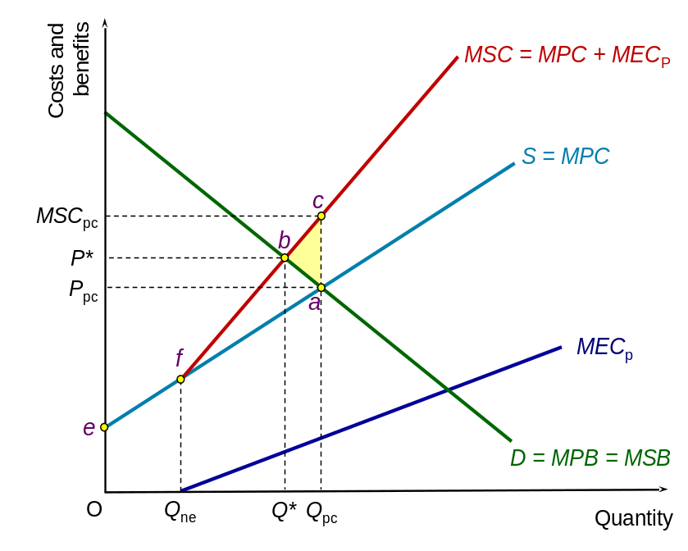

- As

7. Assume there are just two consumers of a pure public good, Suarez and Ronaldo. Their individual demand curves are illustrated in the diagram below – D_{S} and D_{R}

  - Derive the market demand curve for the pure public good.
See the diagram below. Because a pure public good is perfectly non-rivalrous, once a given quantity is produced it can be enjoyed by everyone. Therefore to derive the market demand curve, the individual demand curves of Suarez and Ronaldo need to be vertically added together. The market demand curve is the line abc.
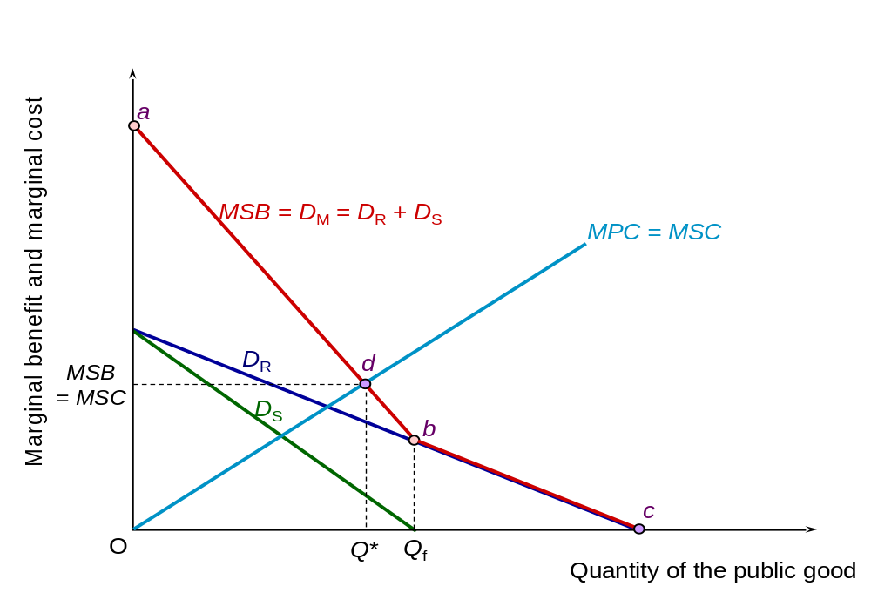
  - Illustrate the socially efficient quantity.
The socially efficient quantity is Q*: the output where MSC = MSB

  - Will the socially efficient quantity be produced in a private market if Suarez and Ronaldo act in perfectly rational and selfish manner?
No. Once the good is produced both Ronaldo and Suarez can consume the good whether they have paid for it or not. Therefore they both have an incentive to free-ride – enjoy the benefits of consuming the good without paying for it. If nobody pays, then a firm cannot generate any revenue and make a profit and so will not produce the good.

